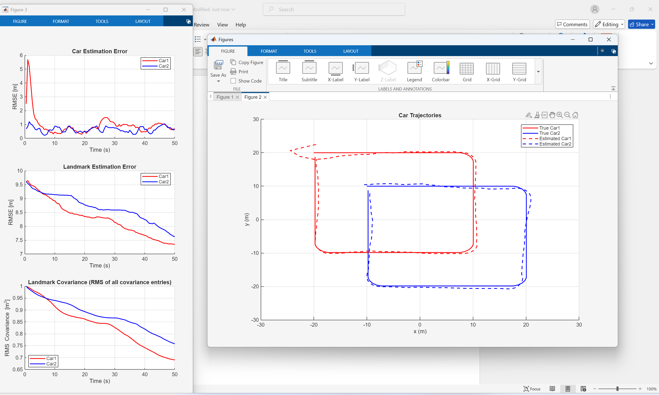
measurement_variance = [2;0.2^2];
P0 = diag([1 1]);
process_variance = [0.1^2; 0.01^2];
P_robot = diag([1, 1, 0.1^2]);
P_landmark = P0;
Average Car1 Position Estimation Error: 0.7622 m
Average Car2 Position Estimation Error: 0.5459 m
Average Landmark Estimation Error from Car1: 8.3730 m
Average Landmark Estimation Error from Car2: 8.0586 m

P0 = diag([0.5 0.5]);

Average Car1 Position Estimation Error: 0.8445 m
Average Car2 Position Estimation Error: 0.5749 m
Average Landmark Estimation Error from Car1: 8.0299 m
Average Landmark Estimation Error from Car2: 8.1699 m

